1.   
   This contains code for web app where we will implement H2 internal DB.

**Agenda**:

* 1. We will store the data from Contact Page into H2 DB.

1. Graphical user interface, website

   Description automatically generated
2. A picture containing text

   Description automatically generated
3. Text

   Description automatically generated
4. 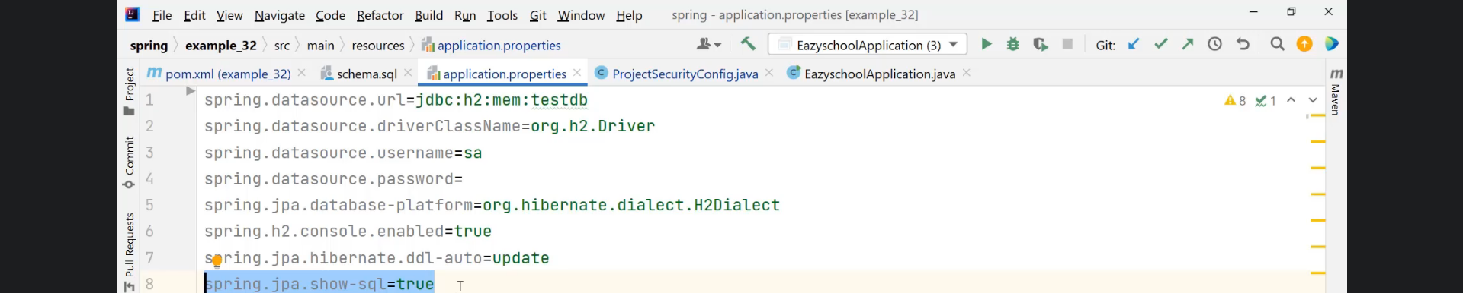 Graphical user interface, text, application

   Description automatically generatedAs we added schema.sql under resource, Spring Boot is smart enough to know to run the scripts in this file.
5. Now, as our java app needs to connect with H2 DB, it internally uses JDBC API and JDBC **needs connection details**.  
   Define in **application.properties file**.  
   Graphical user interface, text, application, chat or text message

   Description automatically generated
6. A picture containing diagram

   Description automatically generatedSince, auto-configuration has a positive match for H2 DB, it is auto-configured all the required classes/beans needed in this app as H2 classes are found.  
   Beans such as
   1. Text

      Description automatically generated
7. Graphical user interface

   Description automatically generated
8. Graphical user interface, text, application, Word

   Description automatically generated
9. Configurations for h2-console path:
   1. **csrf().ignoringAntMatchers(“/h2-console/**”)**:  
      Disabling csrf header protection on this web page “**/h2-console/**”** as we will not going to deploy h2 DB in production.
   2. **authorizeRequests().antMatchers(“/h2-console/**”).permitAll();**Will permit all the paths starting with **/h2-console/\*\***
   3. **http.headers().frameOptions().disable()**:  
      As by default, Spring Security Framework will stop any page that is using frame options because this is a security issue in web app.  
      But unfortunately, our h2-cosole UI code is using frame options to display the content in the browser.
10. Graphical user interface

    Description automatically generated with low confidence
11. Graphical user interface, text

    Description automatically generated
12. Jatin:  
    Graphical user interface, text, application, email

    Description automatically generated